The 4th IIW South –East European Welding Congress
Belgrade, Serbia, October 10-12, 2018
www.seeiiw2018.duzs.org.rs

Sponsorship and Exhibiting Registration Form

Please complete and return the form to:
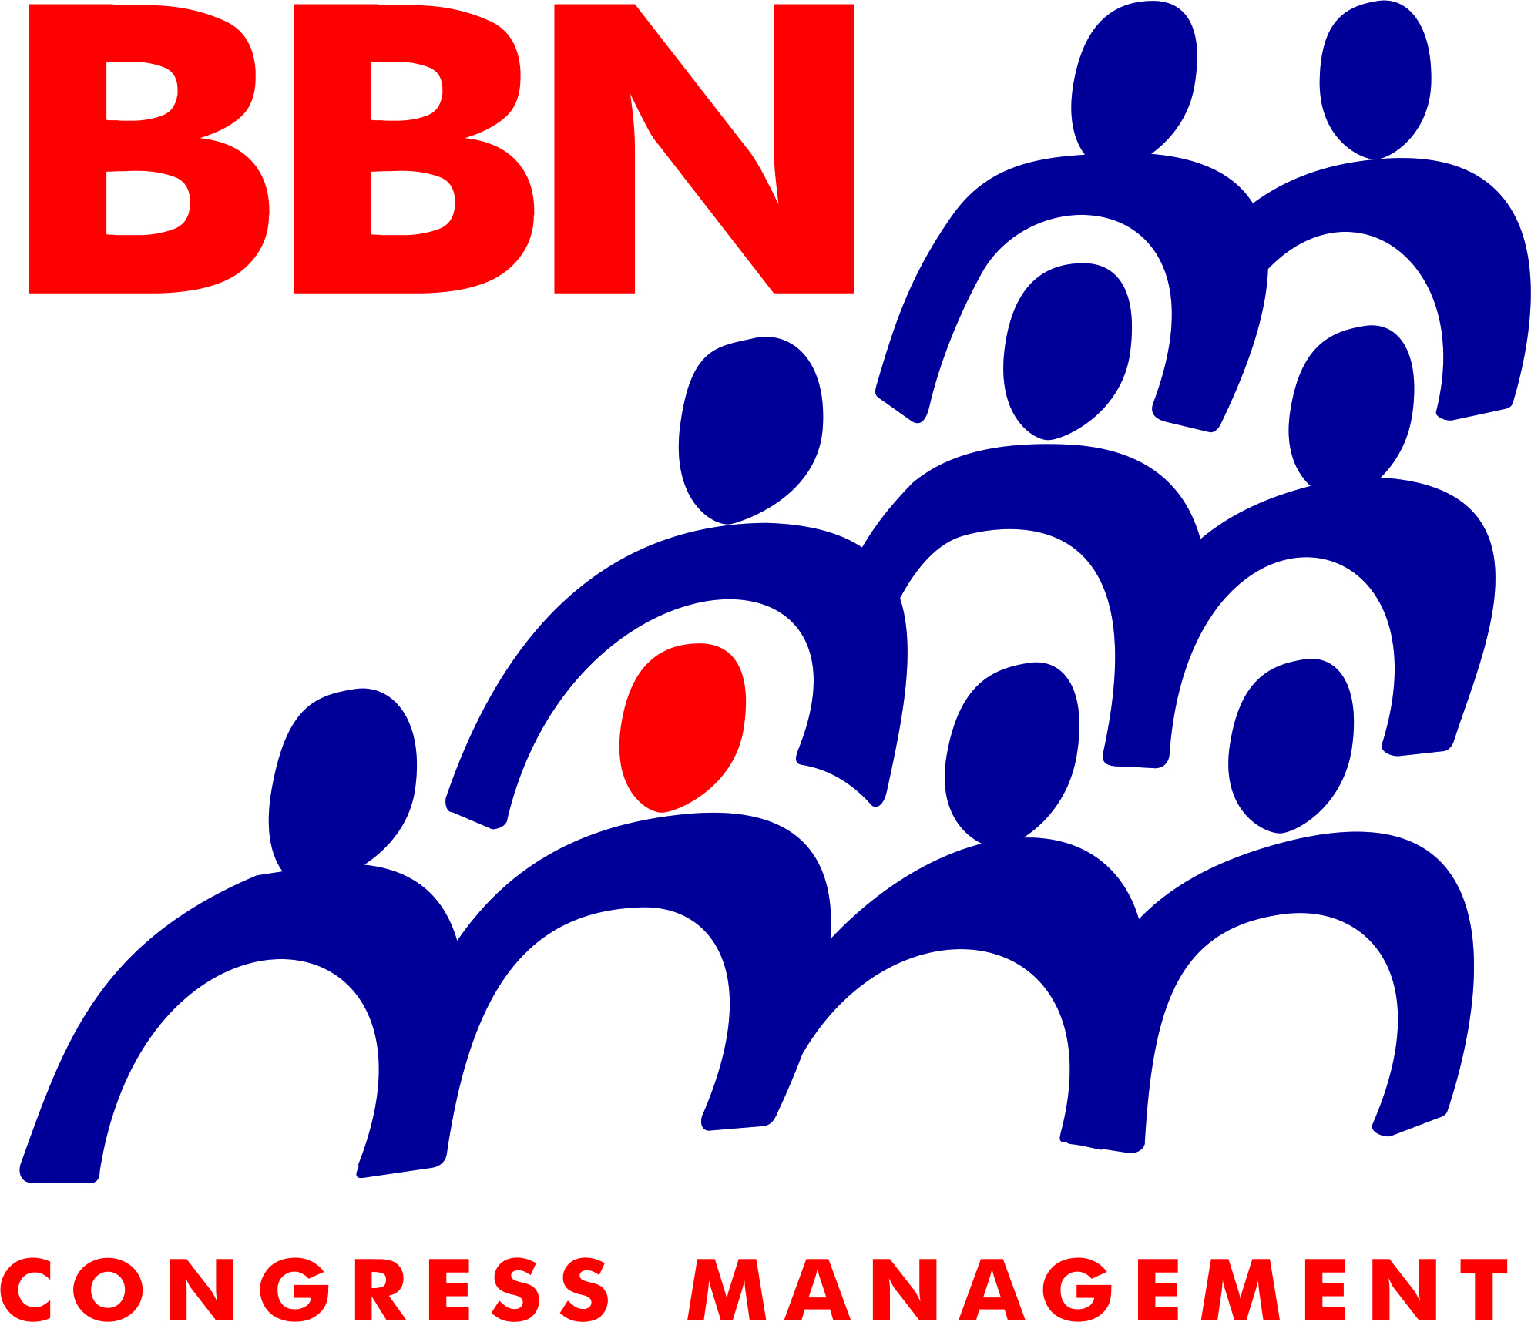
Conference Secretariat: BBN Congress Management, Deligradska 9, Belgrade, 11000, Serbia
Phone: +381(0)113629402, 3629405, 2682318, Mob: +381(0)63368594, Fax: +381(0)113629406
Email: bbn@bbn.co.rs, bbn.pco@gmail.com, Web: www.bbn.co.rs

Company Name:
Contact:
Position:
Address:
City: Zip Code:
Country: Website:
Tel.: Fax:
E-mail:
We would like to become a sponsor at the following level:
☐Platinum sponsor | 10.000€ | ☐Gold sponsor | 5.000€
☐Silver sponsor | 3.000€ | ☐Bronze sponsor | 1.500€
☐Congress Bag sponsor | 3.000€ | ☐Opening Ceremony and  Welcome Cocktail | 1.500€
☐Donor | 400€ | ☐Basic stand (min. 6m²) ____ | 80€/m2
☐ID congress ribbon | 800€ | Advertising in the Congress Program  ☐A4 page black/white colour  ☐1/2 A4 page black/white colour  ☐colour advertisement | 200€  120€  +20%

Payment Methods:
The payment will be made by bank transfer to BBN Congress Management doo:
☐ for payment in EURO (sponsors from abroad)  Bank: UNICREDIT BANK Srbija a.d.  (IBAN) RS35170003000768500115  S.W.I.F.T. BACXRSBG | ☐ for payment in RSD (Serbian sponsors)  Bank: UNICREDIT BANK Srbija a.d.  Account number: 170-30007685000-18
Note: *20% VAT is included

Thank you for your support!

Date: …..…/………/……….. Signature/Stamp: ………………………..…….……

